# **Assignment 17 – Swing GUI**

*“Write a program that converts integers from base ten (ordinary decimal) notation to base two notation. Use Swing to perform input and output via a window interface. The user enters a base ten numeral in one text field and clicks a button with "Convert" written on it; the equivalent base two numeral then appears in another text field. Be sure to label the two text fields. Include a "Clear" button that clears both text fields when clicked.”*

**REVISED:** I believe everything is how it should be, now, except for possibly having done a better job of segmenting things into different methods. Nevertheless, it’s constructed without any proprietary layout schemes, it works, and it will work independent of IntelliJ. Screenshots were not updated. Thanks for allowing me to resubmit.

I created a form with an input field for the decimal, an output for the base two, along with buttons for converting and clearing the fields. The conversion is performed by a private method called binaryReturn() that takes a JTextField object called ‘decimal’ and returns a string. In a try block for exceptions resulting from non-integer input, the getText() function is used to store the JTextField value as a string. The parseInt() function stores the string value as an integer so the toBinaryString() function can return the base two equivalent. I used an if statement to limit the input to whole numbers between 0 and 255 and the output to an octet, just to put some kind of limit on it based on the most likely use.

When the ‘Convert’ button is pressed, actionPerformed() iterates a counter and prints its value to indicate that the conversion has taken place (or at least *tried* to take place) and uses setText() with the binaryReturn() function as its argument to update the appropriate field.

The ‘Clear’ button resets the value of the counter to zero and sets the input and output text fields to empty strings.

There didn’t seem to be a reason to create multiple files/classes in this project so I left it all in one. Also, I googled how to build a JAR with the IntelliJ IDE that I’ve been using, and it’s included in my submission.

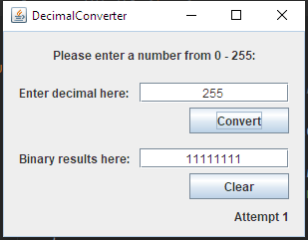

Conversion.

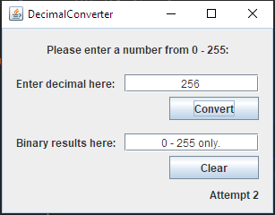

Out of range.

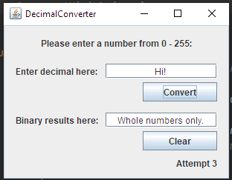

Invalid input.

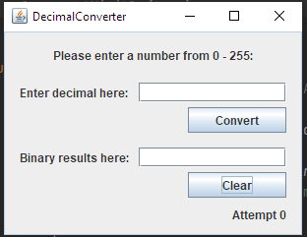

After clear.